Using the PIVOT System to Find Funding Opportunities

The University of New Mexico has purchased the PIVOT system to help researchers find different types of funding opportunities from many different sponsors. The system allows each researcher to set up a personal profile describing their research interests and the PIVOT system will find funding opportunities related to the researchers unique interests. The PIVOT system can also help you find collaborators within other UNM departments that are interested in the same research topics.

- The PIVOT system can be accessed at https://pivot.cos.com/login

- Create an account using your UNM e-mail address so that the system will recognize your affiliation with UNM and allow you to use the system for free.

- Once you log into the system for the first time, click the ‘Profiles’ tab on the top left of the screen. Search for your name. If your name appears, please click it. A tab underneath your job title should say ‘claim profile.’ Please claim your profile.

- Edit your profile to include relevant UNM job titles and all relevant research experience and areas of interest. The system will use these keywords to ask

- When your profile has been created you will then be matched with many different types of research opportunities relevant to your research areas. To view these funding opportunities follow the steps below:
  - Click on the drop down menu next to your name in the top right hand corner of the screen. 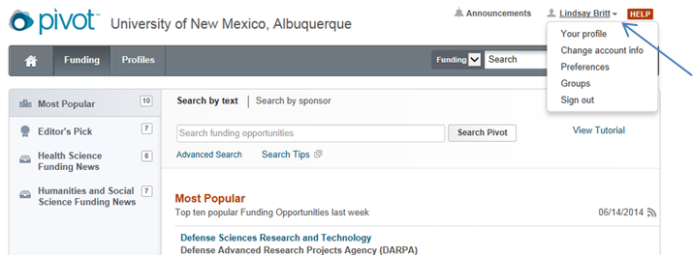
  - From the drop down menu choose “Your Profile.” 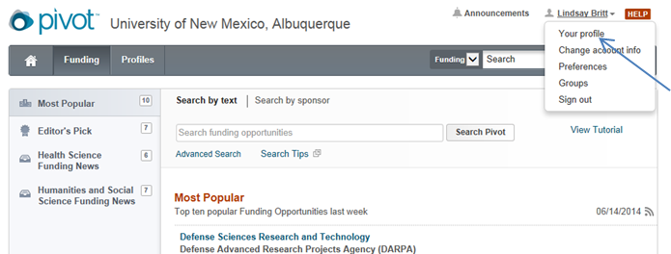
  - On the right hand side of the screen on your profile page there will be a link that says “Funding Matches.” Click on that link to be taken to the list of possible funding opportunities the system has matched you to. 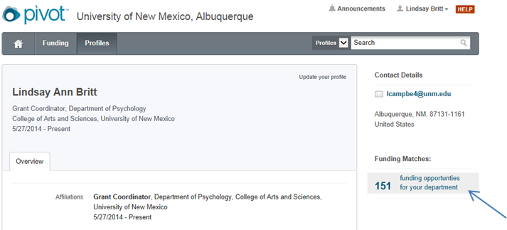
  - Look through the funding opportunities to see if any of them match your research interest.

- If you see a funding opportunity that you would like to apply to right away follow the steps below:
  - Click on the link to the funding opportunity from the results page.
  - On the right hand side of the screen click the “Set to Active” button. This will add the funding opportunity to your “Active” list on the home screen of your account. 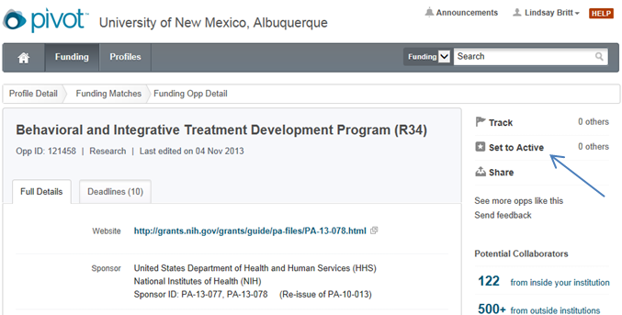

- If you see a funding opportunity that you would like to save for later, or consider applying for in the future follow the steps below:
  - Click on the link to the funding opportunity from the results page.
  - On the right hand side of the screen click the “Track” button. This will add the funding opportunity to your “Tracked” list on the home screen of your account.
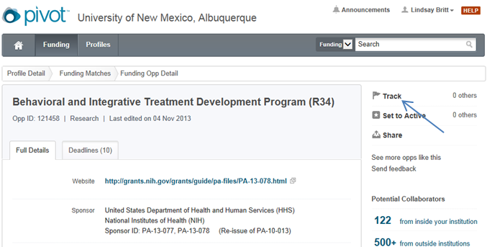

- If you see a funding opportunity that you would like to share with a colleague follow the steps below:
  - Click on the link to the funding opportunity from the results page.
  - On the right hand side of the screen click the “Share” button and type in the e mail address of the person that you would like to share the opportunity with. 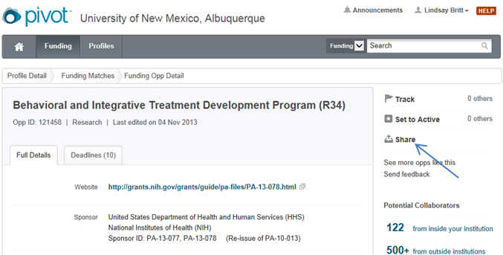

- Once you have decided to apply for a funding opportunity listed in the PIVOT system fill out an Early Alert Form found at http://webcom.unm.edu/ece/research/proposal-submission.html.

- Download the solicitation, begin reading it and draft your proposal. Please work with our Grant Coordinator, Lindsay Britt to being putting together your proposal.

**The PIVOT system has great tutorial videos that can be found by clicking the “Help” button in the top right hand corner of any page in the PIVOT system. Please take a look at these videos if you are having trouble using the system.

